
Mathematics Specialist
Test 4 2016

Integration Techniques &
Applications of Integral Calculus

NAME: _______________________________________________ TEACHER: MLA

Resource Free Section

30 marks
30 minutes

Question 1 [3, 3 & 3 = 9 marks]
Determine the following indefinite integrals:
(a) $\int{{5 tan}^{2}\left(5x\right) dx}$

(b) $\int{27\tan^{2}\left(3x\right)\sec^{2}\left(3x\right) dx}$

(c) $\int{{8 sin}^{2}\left(2x\right) dx}$

Question 2 [5 marks]
Use the substitution $u=1+sin⁡(x)$ to evaluate $\int_{0}^{\frac{π}{2}}{\frac{4cos⁡(x)}{\sqrt{1+sin⁡(x)}}}$

Question 3 [3 & 3 = 6 marks]
- $If f '(x)=\cos\left(x\right)\sin\left(2x\right)$, determine f(x).

- Hence, calculate the area between the curve $y=\cos\left(x\right)\sin\left(2x\right)$and the x-axis from
$x=-\frac{π}{2} to x=π$.
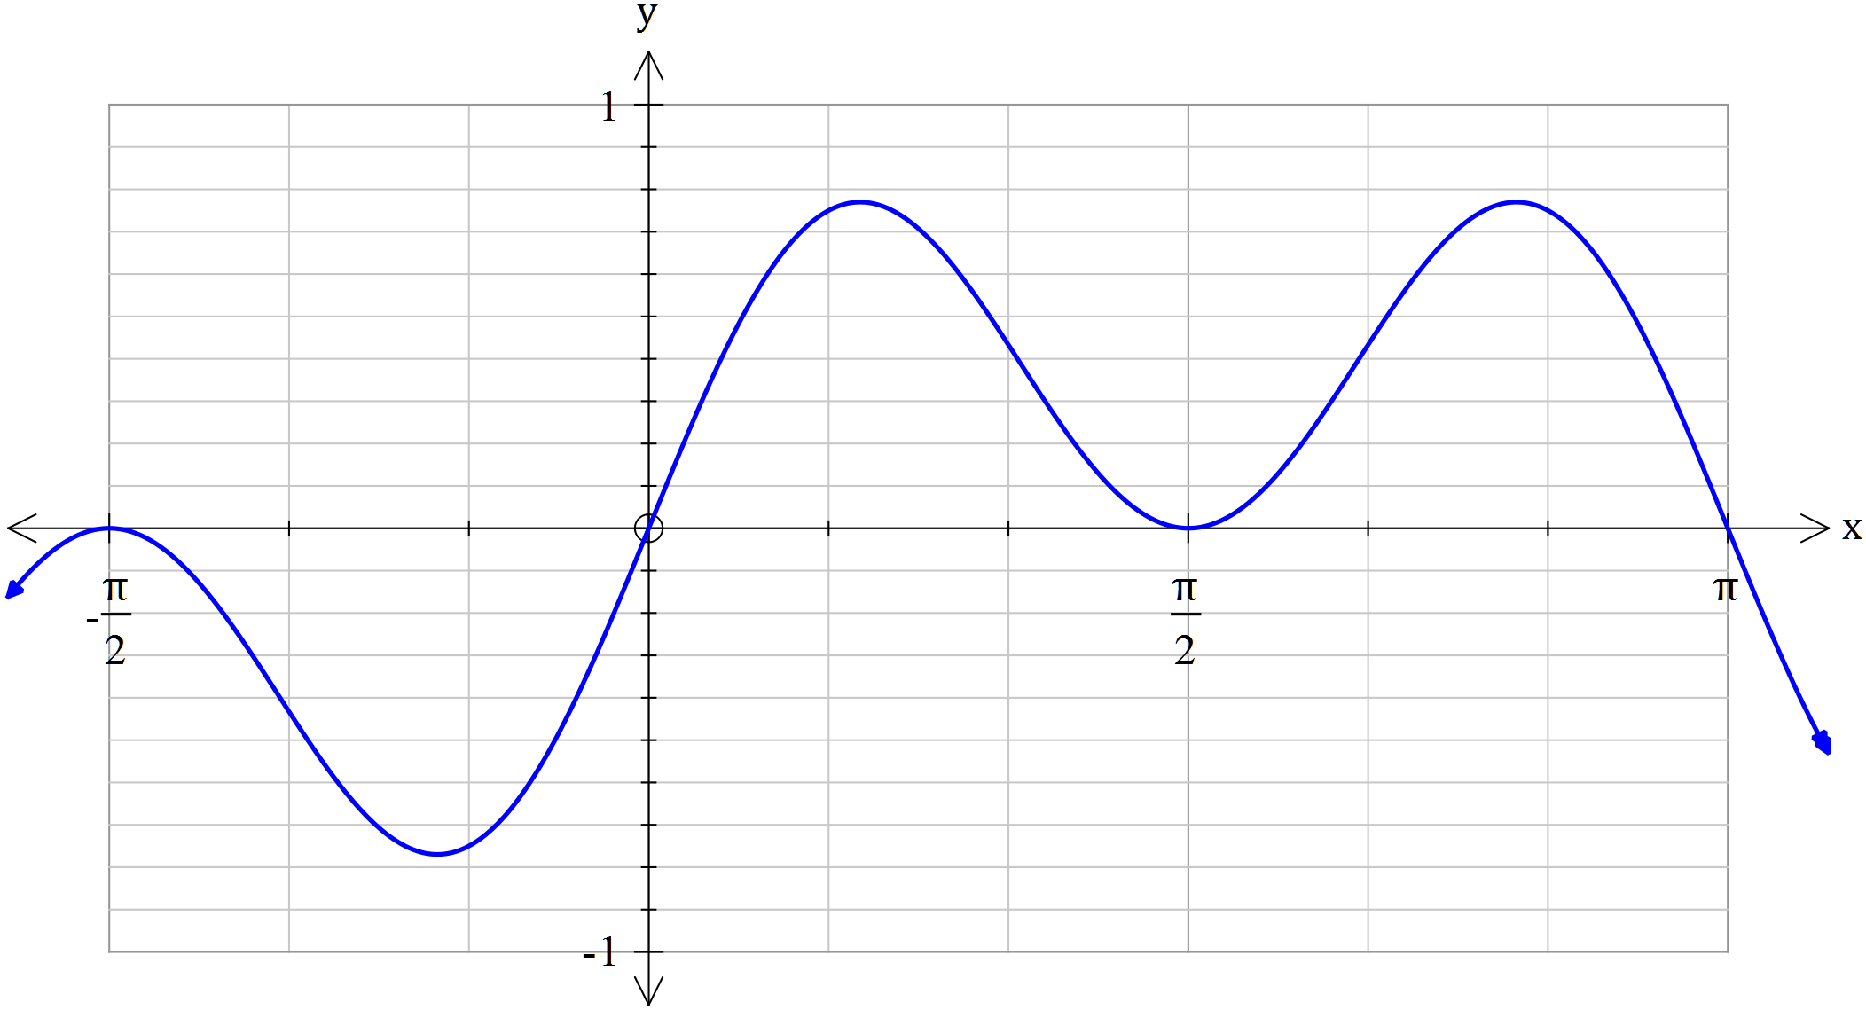
$$y=\cos\left(x\right)\sin\left(2x\right)$$

Question 4 [5 marks]
Calculate the exact volume generated by revolving the area trapped $between y=\frac{1}{x^{2}-1} ,$the vertical axis and the lines $y=-e^{2}$ and $y=-1 about the y axis.$
$$y=\frac{1}{x^{2}-1}$$

Question 5 [2 & 3 = 5 marks]
(a) If$y=ln⁡(x^{x^{2}})$, determine $\frac{dy}{dx}$
Hint 1: Apply a suitable log law to $y=\ln\left(x^{x^{2}}\right)$before differentiating
Hint 2: Do not factorise your final answer

(b) Hence, find$\int{2x\ln\left(x\right) dx}$


Mathematics Specialist
Test 4 2016

Integration Techniques &
Applications of Integral Calculus

NAME: _______________________________________________ TEACHER: MLA

Resource Rich Section

20 marks
20 minutes

One unfolded A4 page of notes, SCSA formulae booklet and ClassPad calculator permitted
Question 6 [1 & 1 = 2 marks]
(a) Express $\int{\frac{x^{2}-x+1}{(x+3)(x^{2}+4)}} dx ,$in exact terms

(b) Evaluate $\int_{0}^{4π}{\frac{x^{2}-x+1}{(x+3)(x^{2}+4)}} dx , correct to 2 decimal places$

Question 7 [6 marks]
Use your knowledge of partial fractions to determine $\int{\frac{7x^{2}-2x+5}{(x-1)(x^{2}+1)}} dx$
Show clear working.

Question 8 [3, 2, 2 & 1 = 8 marks]
Consider the functions$f\left(x\right)=\frac{\sqrt{x} (x^{2}-5x)}{ 2} and g\left(x\right)=-3\sqrt{x}$

A, B and (0, 0) are the three points of intersection of the aforementioned functions.

(a) Draw a neat sketch of f(x) and g(x) on the axes below. Label points A and B.

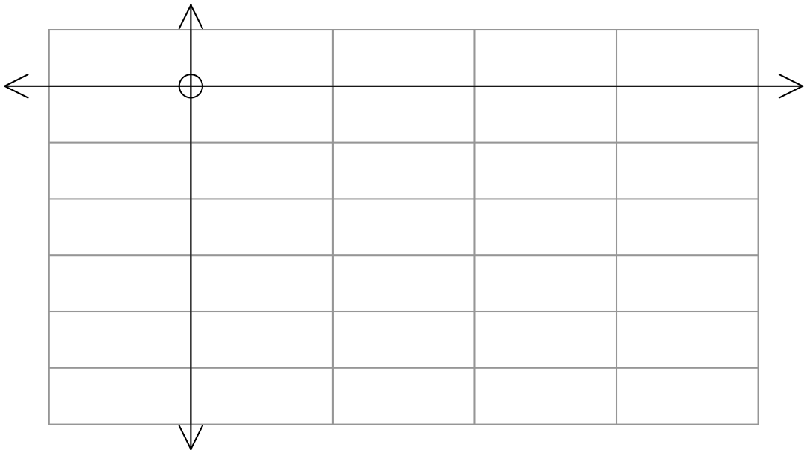

(b) State the ordered pairs for points A and B, correct to 2 decimal places.

(c) State the definite integral that defines the area enclosed by f(x) and g(x) between points A and B.

(d) Use your Classpad to determine the area described in (c).

Question 9 [4 marks]
In geometry, a torus is a surface of revolution generated by revolving a circle in 3-dimensional space about an axis co-planar with the circle.

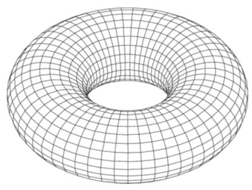

Use calculus to determine the volume of the torus formed by rotating the circle with equation ${ x}^{2}+{(y-2)}^{2}=1$ about the x-axis.

